

**DR. G. Y. PATHRIKAR COLLEGE OF COMPUTER SCIENCE AND INFORMATION TECHNOLOGY, N-6, CIDCO,**

**Chhatrapati Sambhajinagar, Maharashtra, India**

Project Report

On

**Inventory System**

*Submitted by*

**Shehbaaz Khan Gulam Samdani Khan**

*Guided by*

**Dr. Nagsen Bansod Sir**

**BCA. (Science) Sixth Semester,**

**Academic Year 2021-2024**



**DR. G. Y. PATHRIKAR COLLEGE OF COMPUTER SCIENCE AND INFORMATION TECHNOLOGY, N-6, CIDCO,**

**Chhatrapati Sambhajinagar, Maharashtra, India**

**Certificate**

This is to certify that, [NAME OF CANDIDATE]has successfully completed the Project Report on **“[Inventory System ]”** for partial fulfillment of the Program B.C.A(Science) **Sixth Semester**, of MGM University, Dr. G. Y. Pathrikar College of Computer Science and Information Technology, Chhatrapati Sambhajinagar during the Academic Year 2021-2024.

**Seat No: 202103103052**

[**Dr. Nagsen Bansod Sir**] [Mr. Satish Sankaye Sir]

**Project Guide Head of the Department**

**Examiner**

**Acknowledgement**

I would like to express my sincere gratitude and appreciation to all those who contributed to the completion of this project. Their support, guidance, and encouragement were invaluable throughout the journey**.**

First and foremost, I extend my heartfelt thanks to [**Dr. Nagsen Bansod Sir**] for their unwavering support, invaluable guidance, and constructive feedback. Their expertise and insights played a pivotal role in shaping the direction and execution of this project.

I would like to acknowledge the support received from [**DR. G. Y. PATHRIKAR COLLEGE OF COMPUTER SCIENCE AND INFORMATION TECHNOLOGY**] for providing the necessary resources, facilities, and infrastructure to carry out this project.

I am indebted to My Family member and Friends for their understanding, patience, and encouragement during the demanding phases of this project. Their unwavering support kept me motivated and focused.

Last but not least, I extend my gratitude to all those individuals who directly or indirectly contributed to this project. Your contributions, no matter how small, were integral to its success.

In conclusion, I am deeply grateful to everyone mentioned above and to countless others who have played a part in this project. Your support and encouragement have been invaluable, and I am truly honored to have had the opportunity to work with such amazing individuals..

**Abstract**

This paper presents the design and implementation of an inventory management system developed using C# programming language and Microsoft Access database. The system aims to streamline inventory management processes for small to medium-sized businesses by providing efficient tracking, monitoring, and control of inventory items**.**

The system allows Owner to add, update, and delete inventory items, along with their relevant details such as name, description, quantity, and price.

The system seamlessly integrates with a billing module to generate invoices and print bills for completed orders, providing a comprehensive solution for inventory and sales management.

The system is developed using C# programming language for its robustness and flexibility, while Microsoft Access database is utilized for its ease of use and compatibility with small-scale applications. The graphical user interface (GUI) is designed to be intuitive and user-friendly, facilitating easy adoption and minimal training requirements for end-users.

|  |  |
| --- | --- |
| Content | Page No |
| 1. Introduction    1. Existing System.    2. Need and Significance of Proposed System.    3. Objectives and Motivation. | 6 |
| **2**.**System Requirement** | 7 |
| 3.Feasibility Study | 9 |
| 4. Requirement Analysis | 11 |
| 5. Software Requirement Specifications (SRS) | 12 |
| 6. Data Flow Diagram | 14 |
| 7. E-R Diagram | 15 |
| 8.Database Design | 16 |
| 9. User Interface Design | 17 |
| 10. Conclusion | 21 |
| 11.System Limitations | 23 |
| 12.Enhancement | 24 |
| 13. Reports |  |
| 14. Bibliography |  |

1. Introduction

In today's fast-paced business environment, effective inventory management is crucial for the success and sustainability of any organization. Manual inventory tracking systems often prove to be inefficient and error-prone, leading to operational inefficiencies, increased costs, and missed business opportunities. To address these challenges, the implementation of automated inventory management systems has become imperative.

**1.1 Existing System**

Traditionally, many businesses rely on manual methods or outdated software systems for inventory management. These systems often involve labor-intensive processes, such as manual data entry, spreadsheet tracking, and paper-based record-keeping. While such systems may suffice for small-scale operations, they lack the scalability, accuracy, and real-time capabilities required to meet the demands of modern businesses.

**1.2 Need and Significance of Proposed System**

The need for a more efficient and robust inventory management system is evident. The proposed system aims to address the limitations of the existing methods by leveraging the power of technology to streamline inventory-related processes. By automating tasks such as inventory tracking, order processing, and reporting, the proposed system seeks to optimize resource utilization, minimize errors, and improve overall operational efficiency.

The significance of the proposed system lies in its potential to transform the way businesses manage their inventory. By providing accurate, real-time insights into inventory levels, sales trends, and customer preferences, the system empowers businesses to make informed decisions, reduce stockouts, and enhance customer satisfaction. Moreover, the system's integration with billing functionality offers a seamless end-to-end solution for inventory management and sales processing.

**1.3 Objectives and Motivation**

The primary objectives of this project are as follows:

Design and develop a comprehensive inventory management system using C# programming language and Microsoft Access database.

Implement features such as inventory tracking, order processing, reporting, and billing to meet the diverse needs of businesses.

Enhance user experience through an intuitive graphical user interface (GUI) and seamless integration with existing workflows.

Ensure scalability, reliability, and security to support the long-term growth and sustainability of the system.

The motivation behind this project stems from the desire to address the challenges faced by businesses in managing their inventory effectively. By leveraging technology to automate and streamline inventory-related processes, we aim to empower businesses to optimize their operations, reduce costs, and stay competitive in today's dynamic marketplace.

**System Requirement**

1. **Hardware Requirements:**
   * Processor: Intel Core i5 or equivalent
   * RAM: 8GB or higher
   * Storage: Minimum 100GB HDD/SSD
   * Printer: Compatible printer for bill printing
2. **Software Requirements:**
   * Operating System: Windows 10 or later
   * Development Environment: Microsoft Visual Studio
   * Database Management System: Microsoft Access
   * Programming Language: C# (.NET Framework or .NET Core)
   * Additional Libraries: Any necessary C# libraries for database connectivity and bill printing functionality
3. **Functional Requirements:**
   * **Inventory Management:** Ability to add, update, and delete inventory items, along with their relevant details such as name, description, quantity, and price.
   * **Order Processing:** Creation, editing, and fulfillment of orders, with automatic updates to inventory levels upon order placement or fulfillment.
   * **Reporting and Analytics:** Generation of various reports such as inventory status, sales analysis, and reordering recommendations.
   * **User Authentication and Authorization:** Role-based access control to ensure secure access to system functionalities.
   * **Billing Integration:** Seamless integration with a billing module for generating invoices and printing bills for completed orders.

**Feasibility study**

Before embarking on any project, it is essential to conduct a feasibility study to assess the viability and potential success of the endeavor. In the context of this Inventory System, the feasibility study examines various aspects to determine its feasibility:

1. **Technical Feasibility:** The technical feasibility assesses whether the proposed system can be developed using available technology and resources. In this case, the use of C# programming language and Access database ensures technical feasibility, given their widespread availability and compatibility.
2. **Economic Feasibility:** Economic feasibility evaluates the cost-effectiveness of developing and implementing the Inventory System. While there may be initial investment costs associated with software development and database setup, the long-term benefits of improved inventory management and operational efficiency outweigh these costs.
3. **Operational Feasibility:** Operational feasibility examines whether the proposed system aligns with the existing business processes and can be effectively integrated into the organization's workflow. The user-friendly interface of the Inventory System and its seamless integration with existing systems ensure operational feasibility, minimizing disruptions to daily operations.
4. **Legal and Regulatory Feasibility:** Legal and regulatory feasibility assesses whether the proposed system complies with relevant laws, regulations, and industry standards. By adhering to best practices in software development and data management, the Inventory System ensures legal and regulatory compliance.

**Requirement analysis**

Requirement analysis is a critical phase in the development of any software project, including an inventory system with bill printing functionality. It involves gathering, documenting, and analyzing the needs and expectations of stakeholders to ensure that the final product meets their requirements effectively. Here are some key aspects of requirement analysis for this project:

1. **Functional Requirements**: Identify the core functionalities that the inventory system must provide, such as:
   * Inventory Management: Adding, updating, and deleting inventory items.
   * Order Processing: Creating, editing, and fulfilling orders, with automatic inventory updates.
   * Reporting: Generating various reports like inventory status, sales analysis, etc.
   * Billing Integration: Seamless integration with billing functionality to print bills for completed orders.
2. **Non-Functional Requirements**: Consider non-functional aspects like performance, security, usability, and scalability:
   * Performance: Ensuring the system operates efficiently even with large volumes of data.
   * Security: Implementing user authentication and authorization mechanisms to protect sensitive information.
   * Usability: Designing an intuitive user interface to facilitate easy navigation and operation.
   * Scalability: Ensuring the system can accommodate future growth and expansion of the business.
3. **User Requirements**: Understand the needs and preferences of end-users, including:
   * User Roles: Identifying different user roles and their corresponding permissions within the system.
   * User Interface Preferences: Gathering feedback on user interface design preferences and usability requirements.
   * Training and Support: Assessing the need for training materials and ongoing support for users.
4. **Technical Requirements**: Determine the technical environment and constraints for the system:
   * Programming Language and Database: Choosing C# for development and Access database for storage.
   * Hardware and Software Dependencies: Identifying hardware and software requirements for deploying the system.
   * Integration Requirements: Assessing integration points with external systems, such as billing software for printing bills.

**Software Requirement Specifications (SRS).**

The Software Requirements Specifications (SRS) document outlines the detailed requirements and specifications for the development of the inventory management system. It serves as a blueprint for the project, guiding the design, development, and testing phases. The SRS document typically includes the following sections:

1. **Introduction:** Provides an overview of the project, its objectives, and scope.
2. **Functional Requirements:** Describes the functionalities and features expected from the system, including user interactions, data processing, and system behavior.
3. **Non-Functional Requirements:** Specifies the non-functional aspects of the system, such as performance, reliability, security, and usability.
4. **User Interfaces:** Details the design and layout of user interfaces, including screens, forms, and navigation.
5. **Data Requirements:** Defines the data structures, storage mechanisms, and database schema required for the system.
6. **External Interfaces:** Describes any external systems or services that the inventory system needs to interact with, such as payment gateways or third-party APIs.
7. **Constraints and Assumptions:** Identifies any constraints or assumptions that may impact the development or usage of the system.

Data Flow Diagram

Inventory Management

Customer Management

Receiving Stock

Management

Payment Managemet

Supplier

Management

Purchasing Management

E-R Diagram:

DailyBillNo

Receipt No

TotalPenddingBalance

CustLID

Customer Type

Customer

ID

TranscationDate

CustID

Customer Name

Paid

Amount

Customer Ledger

Balance Amount

TransactionAmt

Customer Address

Customer

Contact No

CustomerName

CurrentBalancee

Customer

Shop Name

BillNo

Bill No

DailyBillNo

SDate

OldBalance

Sales ID

status

Sales

CustomerName

CustomerType

TotalQty

Discount

TotalAmount

TotalItem

BalanceAmount

PaidAmount

Database Design:

**Customer Table:**

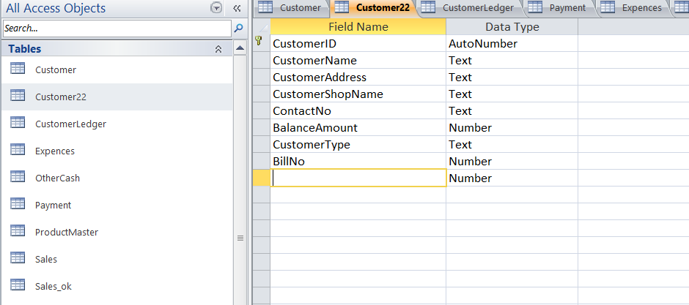

This is customer Ledger table

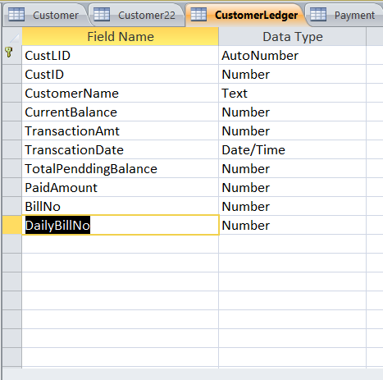

This is Sales Table:

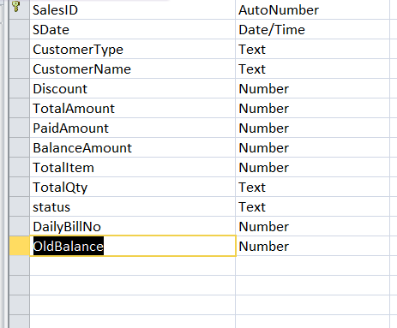

User Interface Design:

This is the first page of the system .here we hava data GridView so first we enter the item which customer purch ,and we click on the check buttom so in this case the item list save in the sales table and also print the bill.

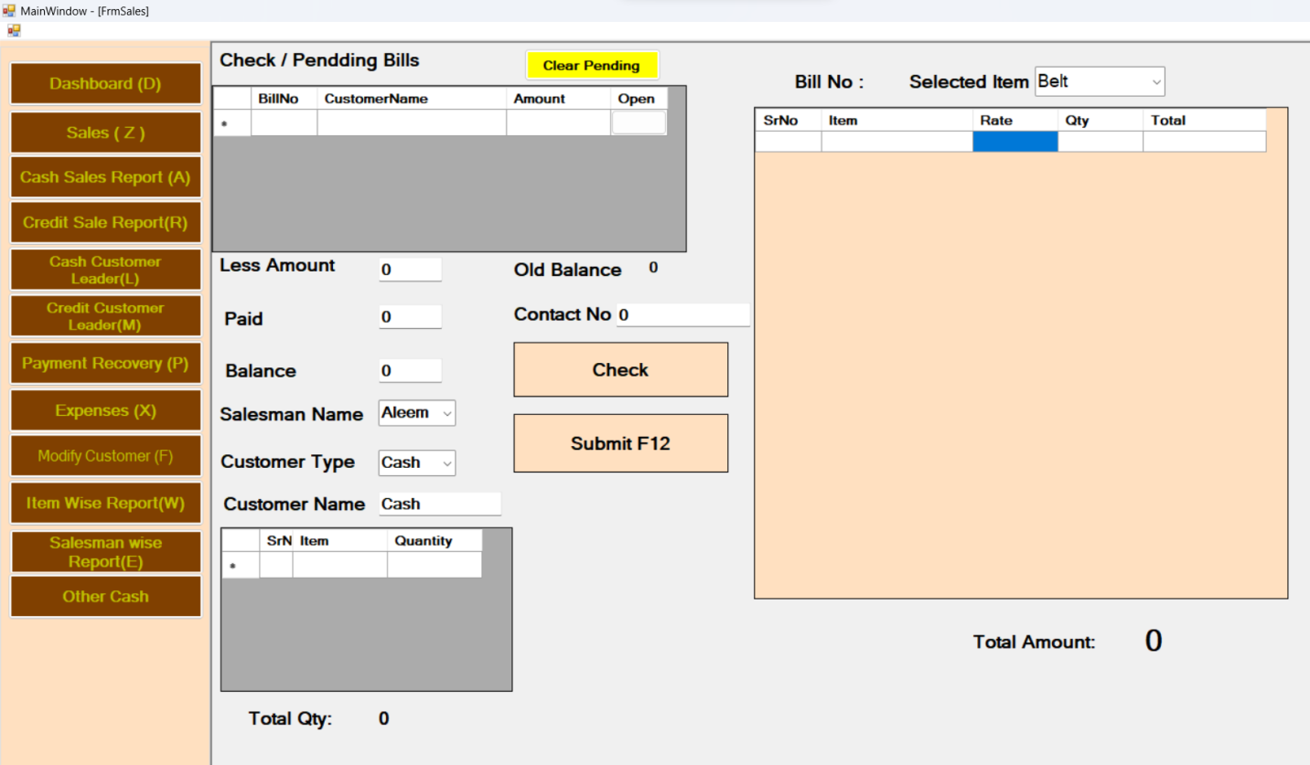

**So we use here SQL statement for insert the record in the data base and for print bill we write code.**

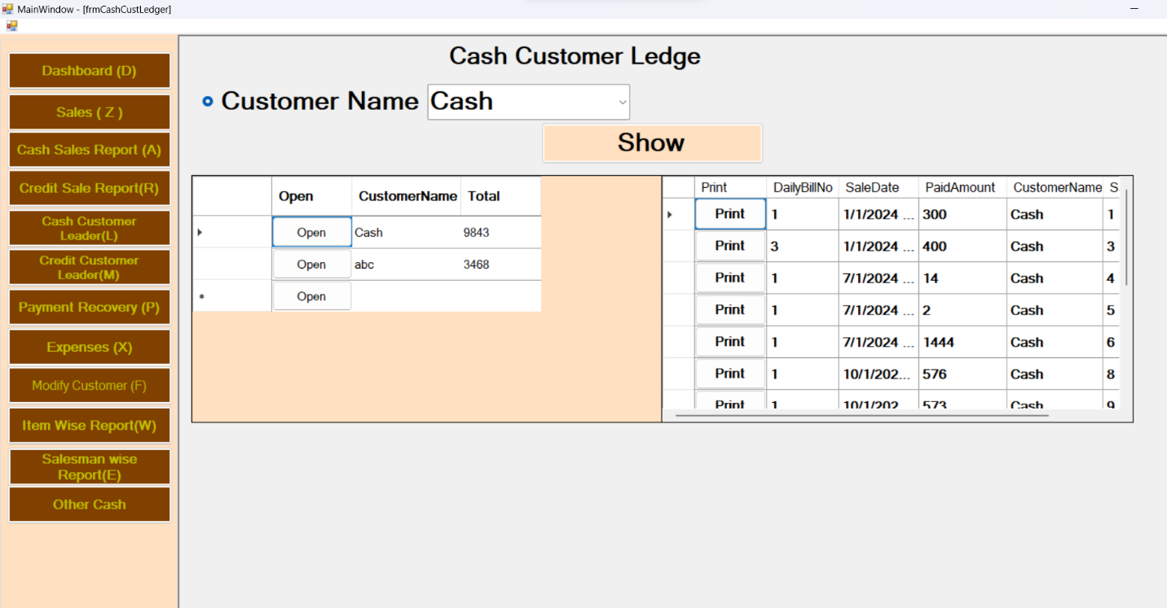

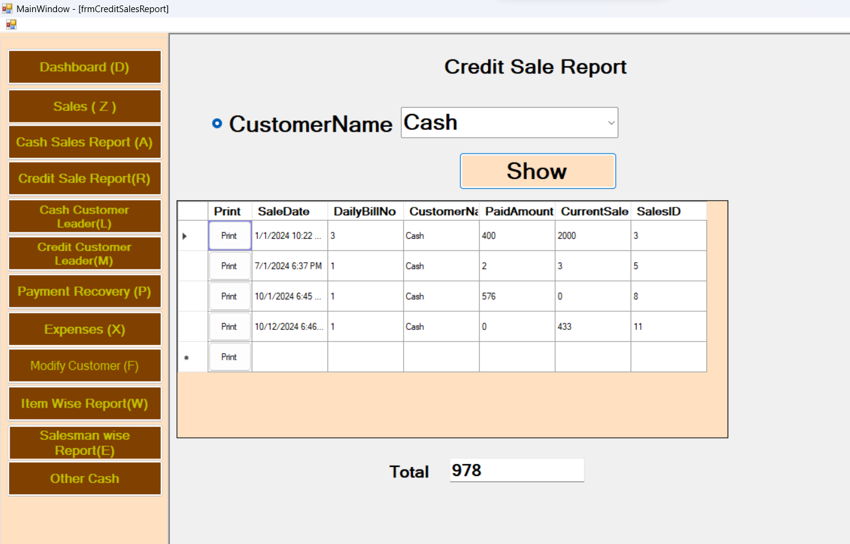

Conclusion:

In the fast-paced automotive industry, the need for streamlined operations and enhanced customer experiences is paramount. The development and implementation of a Customer Management Inventory System tailored for garage settings stand as a pivotal step toward revolutionizing the way automotive service centers operate.

By amalgamating cutting-edge technology with industry-specific functionalities, this system aims to address the unique challenges faced by garage owners and managers. Through meticulous database management, streamlined inventory control, and personalized customer service, the system promises an array of benefits:

* **Enhanced Efficiency:** Centralized data management and streamlined workflows optimize operational efficiency, reducing redundancies and minimizing manual errors.
* **Customer-Centric Approach:** Comprehensive customer profiles, service histories, and personalized interactions foster stronger relationships and increased customer satisfaction.
* **Informed Decision-Making:** Data-driven insights generated through robust reporting and analytics empower stakeholders to make informed decisions, driving business growth and strategy.

This Customer Management Inventory System represents not only a technological advancement but a strategic investment in the future of garage operations. By prioritizing efficiency, customer satisfaction, and data-driven decision-making, it promises to elevate the standards of service within the automotive repair industry.

In conclusion, the integration of this system into garage operations signifies a paradigm shift toward a more efficient, customer-centric, and future-ready approach, positioning garages to thrive in an increasingly competitive landscape.

System limitations:

The limitations of a Customer Management System can vary depending on the specific system in use, but some common limitations may include:

1. Scalability: Some systems may have limitations in terms of the number of customers, products, or transactions they can efficiently handle. As the business grows, the system may struggle to keep up with increasing data volume.
2. Integration: System limitations may arise when attempting to integrate the Customer Management Inventory System with other software or platforms used in the business. Incompatibility or difficulty in syncing data can be a challenge.
3. Customization: Certain systems may have limitations in terms of customization to fit unique business processes and requirements. This can restrict flexibility and adaptability to changing business needs.
4. Reporting and Analytics: The system may have limitations in generating custom reports or advanced analytical capabilities, which can hinder in-depth insights into customer behavior and inventory management.
5. User Limitations: Some systems may have restrictions on the number of users or concurrent access, which can impact collaboration and accessibility for employees.
6. Technical Support: Depending on the system, limitations in technical support or updates may exist, leading to potential challenges in maintaining and troubleshooting the system.

Enhancements:

Enhancements for a Customer Management Inventory System could include various features and improvements such as:

1. Advanced Reporting and Analytics: Implementing more robust reporting capabilities and data visualization tools to gain valuable insights into customer behavior, inventory trends, and business performance.
2. Integration with E-commerce Platforms: Enhancing the system's ability to seamlessly integrate with e-commerce platforms to synchronize inventory data, manage customer interactions, and streamline order fulfillment processes.
3. Mobile Application Support: Developing a mobile-friendly interface or dedicated mobile application to allow on-the-go access to customer and inventory information, as well as the ability to perform key functions remotely.
4. Customer Relationship Management (CRM) Integration: Integrating the system with a CRM platform to centralize customer information, improve customer communication, and enable targeted marketing and sales activities.
5. Automated Inventory Replenishment: Adding automated triggers and notifications for low inventory levels, enabling the system to generate purchase orders or alerts for reordering stock.
6. Customer Self-Service Portal: Introducing a self-service portal for customers to view their account details, track orders, and manage their preferences, reducing the workload on customer service staff.
7. Enhanced Security Features: Strengthening data security measures to protect customer and inventory information from unauthorized access or breaches.
8. Personalization and Customization Options: Offering customization features to tailor the system to specific business needs and enable personalized customer interactions.
9. Workflow Automation: Streamlining operational workflows through automation, such as automated order processing, invoicing, and shipment tracking, to improve efficiency and reduce manual errors.